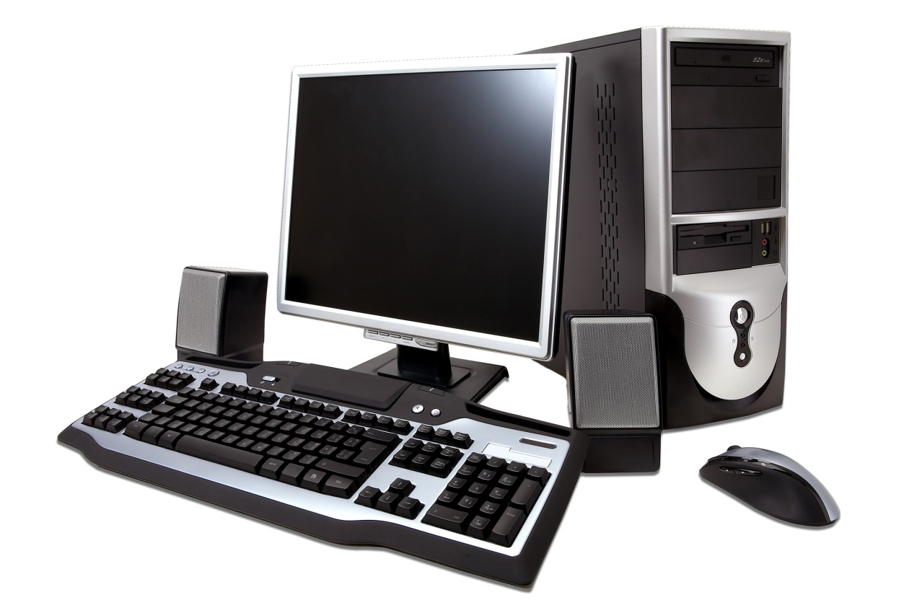

Keep up with all the news in the world of computers.

  - Advances in hardware
  - Reviews of software and hardware
  - Guidelines for purchasing
  - Tips and Tricks for your software, including Win95, Win 98 and WinXP

Only $24 per year for 12 issues.

Don’t Delay, Subscribe Now!

Call Angel Montcalm at (519) 567-8900. We accept VISA and Mastercard for phone orders. Or write subscription, Computers Today, 23456 Yonge Street, Toronto, ON, M5G 9K0

